CEO Note To Staff
Subject: Introducing Visionflex Virtual Care at [Site]
Dear [Team],
I’m pleased to announce that [Organisation] is launching Visionflex Virtual Care technology at [Site] from [Go-Live Date].

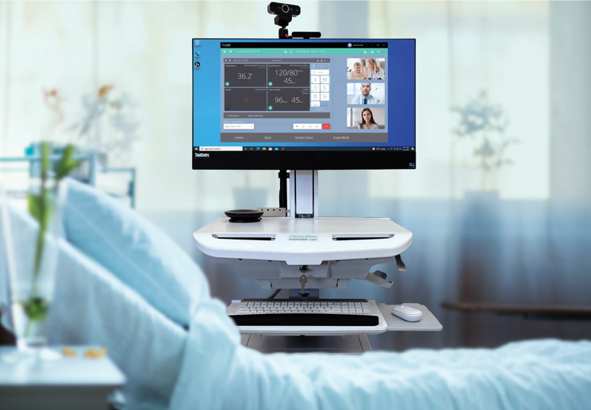
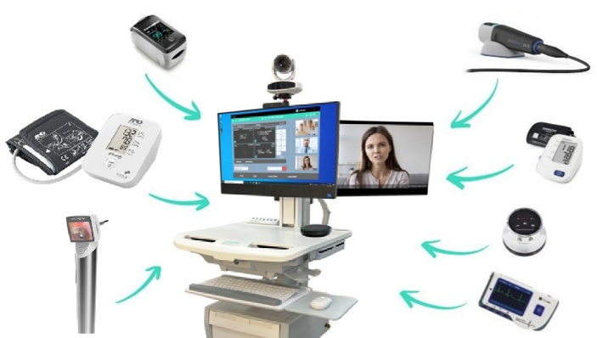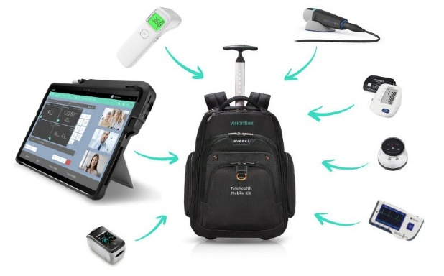

This new capability supports safer, more connected patient care by enabling high-quality virtual consultations. It will help us reduce delays, improve access to specialist advice, and enhance the experience for patients when an in-person visit isn’t required or practical.
This initiative is part of our ongoing commitment to modernise care delivery while maintaining the highest clinical standards. We have worked with clinical leaders, IT, and Visionflex to ensure a smooth rollout with strong privacy, consent, and safety steps built in.
Over the coming weeks you will receive information about training sessions, how virtual consults fit into your workflows, and who your local champions are for support.
Thank you for your professionalism and engagement as we adopt this important technology.
Warm regards,
[CEO Name]
Chief Executive Officer
[Organisation]
Useful policy link (optional): AHPRA guidance on virtual care standards: https://www.ahpra.gov.au/Resources/Information-for-practitioners-who-provide-virtual-care.aspx
Staff Launch Email (pre-go-live)
Subject: Staff update: Visionflex Virtual Care launch on [Date]
Hi [Team],
We are now two weeks out from launching Visionflex Virtual Care at [Site] on [Go-Live Date].
This means that selected consultations will be delivered virtually using the Visionflex platform. This is not a pilot, it is a new way of working that will become part of our routine care model.
What you need to know now
Training: You are invited to attend a short training session. Please see the details below and complete your session before go-live.
Workflows: We have agreed Phase 1 workflows that include clear steps for consent, privacy, documentation, and escalation.
Support: Local champions ([Names]) and Visionflex support are available if you need help.
Training schedule
[List session dates/time, location/virtual link]
Please review the attached one-pager, How Virtual Care Works, before your scheduled training.
Thank you for your participation and support.
Best,
[Project Lead Name]
Project Lead – Virtual Care Deployment

Champion Invite
Subject: Champion invitation: Visionflex Virtual Care rollout
Dear [Champion Name],
Thank you for agreeing to be a local champion for our Visionflex Virtual Care launch at [Site].
Champions help their peers with workflow questions, reinforce best practice, and provide early feedback during the first two weeks after go-live. Your role is critical in making this a success.
We will run a dedicated Train-the-Trainer session on [Date/Time]. Attendance is essential so you can confidently support your team.
What you’ll help with
• Encourage adoption of the agreed workflows
• Support consent, privacy steps, and documentation standards
• Assist colleagues with basic technology questions
• Log issues and escalate where needed
Attached are the Champion One-Pager and Scheduling Guide. Please reply to confirm attendance.
Warm regards,
[Project Lead Name]

GP / External Clinician Invite
Subject: Invitation: Join Virtual Consultations via Visionflex
Dear [GP / Specialist Name],
[Organisation] is launching Visionflex Virtual Care at [Site] on [Go-Live Date].


We would like to invite you to join virtual consultations as part of our care pathways. Visionflex supports secure, high-quality sessions with integrated peripheral capability as required.
What you need to do next
- Schedule a short test call with our team – [Link to scheduler or contact]
- Review the attached External Clinician Guide
- Identify preferred times and contact details for consult invitations
We look forward to partnering with you in delivering timely, connected care to our patients.
Kind regards,
[Clinical Lead / Project Lead]

“How It Works” One-Pager (for staff and patients)
Title: How Visionflex Virtual Care Works at [Site]
What it is
Visionflex Virtual Care lets clinicians and patients connect via secure video for selected consultations where appropriate.
When we use it
• Follow-up reviews
• Specialist advice
• Non-urgent clinical assessments where virtual is appropriate
What happens in a session
- The appointment is booked
- Staff confirm identity and consent
- Clinical assessment occurs via video
- Notes are documented in the patient record
Privacy and consent
We confirm consent at the start of every consult. Consults are not recorded unless agreed and approved.
If technology fails
We fall back to audio or reschedule if required and clinically safe.
Support
Local champions: [Names/Contacts]
Visionflex support: [email / phone]
What you should know (patients)
• You will receive a link or SMS for your virtual visit
• Ensure you are in a quiet, private place
• Tell us if someone is with you before we start
Links
Virtual care expectations (AHPRA): https://www.ahpra.gov.au/Resources/Information-for-practitioners-who-provide-virtual-care.aspx
Patient privacy info: https://www.oaic.gov.au/privacy/health-service-providers/guide-to-health-privacy

