How to use this kit
This kit contains ready-to-use templates for communicating a Visionflex Virtual Care roll-out in a residential aged care home (RACH). Replace placeholders in brackets, then publish in your usual channels (email, Teams, intranet, printed posters).
- Use the CEO or Executive Sponsor note to set the tone and priority.
- Send the staff launch email 2 weeks before go-live and again 2 days before go-live.
- Invite local champions early and run a dedicated train-the-trainer session.
- Invite external clinicians (GPs, allied health, specialists) and book a short test call before the first resident consult.
- Provide residents and families with a clear explanation of what will happen, privacy, consent, and who to contact.
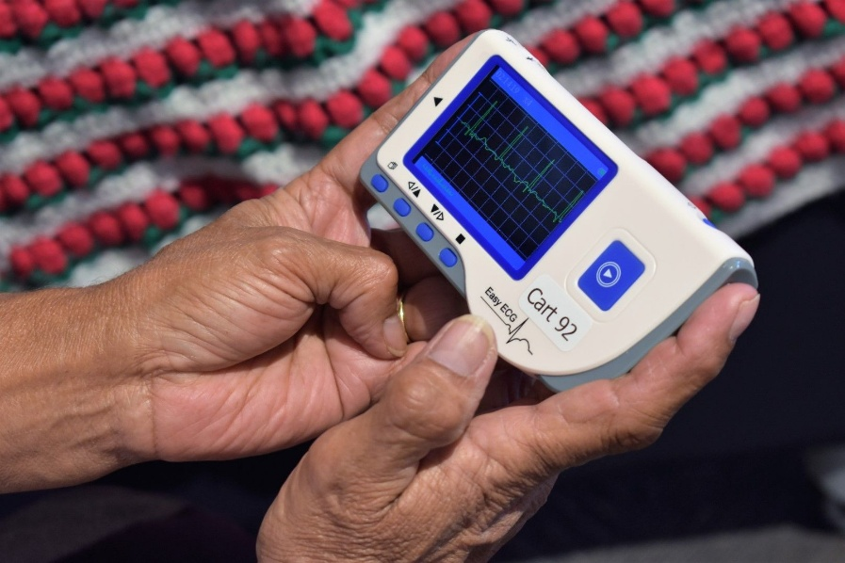
CEO Note To Staff
Subject: Introducing Visionflex Virtual Care at [Site]
Dear [Team],
I am pleased to announce that [Organisation] is launching Visionflex Virtual Care at [Home] from [Go-live date].
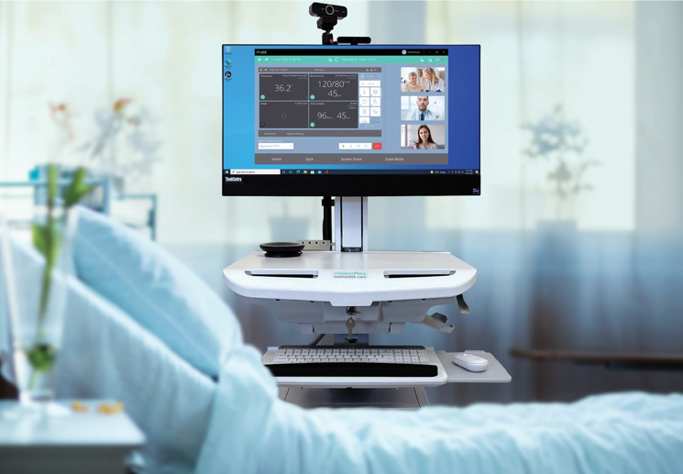
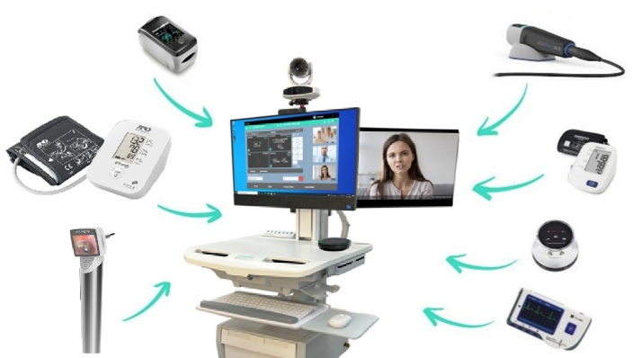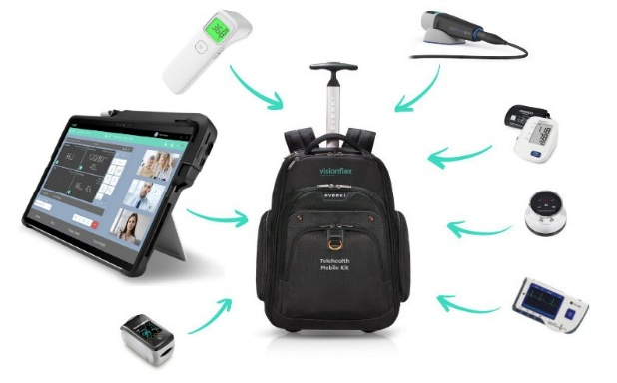

Virtual care supports safer, more connected care by enabling high-quality video consultations, with clinical tools available during the call when required. It helps us reduce delays, improve access to GPs and specialists, and support timely decision making for residents without unnecessary travel.
This initiative is part of our commitment to strengthen clinical care, lift consistency, and support our teams with better access to external providers. We have worked with our clinical leaders, IT, and Visionflex to ensure privacy, consent, and safety steps are built into the workflow.
Over the coming weeks you will receive training invitations, workflow guidance, and details of local champions who can support you.
Thank you for your professionalism and engagement as we embed this capability into day-to-day care.

Kind regards,
[Name]
[Title]
[Organisation]

Useful policy link (optional): AHPRA guidance on virtual care standards: https://www.ahpra.gov.au/Resources/Information-for-practitioners-who-provide-virtual-care.aspx

Staff Launch Email (pre-go-live)
Subject: Staff update: Visionflex Virtual Care launch on [Date]
Hi [Team],
We are now two weeks out from launching Visionflex Virtual Care at [Site] on [Go-Live Date].
We are two weeks out from launching Visionflex Virtual Care at [Home] on [Go-live date]. This is not a pilot. It is a new way of working that will become part of our routine model of care.
What you need to know now
Training: Please attend a short training session before go-live. Details are below.
Workflows: Phase 1 workflows are confirmed, including consent, privacy, documentation, escalation, and technology failover.
Support: Local champions ([Names]) will be available on shift, and Visionflex Support is available during business hours.

Training schedule
[Insert session dates, times, location or Vision Training Invitation link]

Thank you,
[Project Lead name]
[Role]

Staff reminder (2 days pre go-live)
Subject: Reminder: Virtual Care go-live on [Date] and where to get help
Hi team,

A quick reminder that Visionflex Virtual Care goes live at [Home] on [Go-live date].

Where to get help
On shift champions: [Names, roles]
Local project lead: [Name, phone]
Visionflex Support: 02 8914 4000 or support@visionflex.com (9.00am to 5.30pm AEST, Mon to Fri)

If you have not completed training, please attend the next session or contact [Project Lead] to arrange a short catch-up.

Thank you,
[Project Lead]

Champion Invite
Subject: Champion invitation: Visionflex Virtual Care roll-out at [Home]
Dear [Name],

Thank you for agreeing to be a local champion for the Visionflex Virtual Care roll-out at [Home].
Champions help peers with workflow questions, reinforce best practice (consent, privacy, documentation, escalation), and provide early feedback during the first month after go-live.
We will run a train-the-trainer session on [Date/Time]. Please confirm your attendance.
What you will help with
- Support staff to follow the agreed workflows
- Assist with basic equipment setup and room readiness
- Encourage routine use for the Phase 1 use cases
- Log issues and escalate as needed

Kind regards,
[Project Lead]

External provider invitations
Use the templates below to invite the providers who will join sessions: GPs, Nurse Practitioners, allied health, specialists, pharmacists, and hospital teams.

Invitation to GP practice / Responsible Provider (GPACI where relevant)
Subject: Invitation: Virtual consults with [Home] via Visionflex
Dear Dr [Name] and team,

[Organisation] is launching Visionflex Virtual Care at [Home] on [Go-live date]. We would like to offer virtual consultations as part of our routine care pathways, supported by our onsite nursing team.

Visionflex enables a high-quality video consult, with optional clinical peripherals (for example, digital stethoscope, ECG, vital signs, exam camera) to support remote clinical decision making when appropriate.
Next steps
1. Book a 10-minute test call with our team: [Link or contact]
2. Confirm the best email and mobile number for sending session invitations
3. Share preferred days and times for scheduled virtual rounds or urgent reviews
We look forward to partnering with you to improve access, continuity, and timely care for residents.

Kind regards,
[Clinical Lead name]
[Role]
[Home] | [Organisation]

Invitation to allied health / specialist providers
Subject: Invitation: Provide virtual consultations to residents at [Home]
Hello [Name],

[Organisation] is enabling virtual consultations for residents at [Home] using the Visionflex platform from [Go-live date].
We would like to invite you to participate in supported virtual consults. Our nursing team will be onsite with the resident to assist with setup, consent confirmation, and any required clinical observations.

Next steps
1. Book a short test call: [Link or contact]
2. Confirm booking and referral pathway (who sends referrals, what information you need in advance)
3. Confirm any equipment needs for your typical consults (for example, wound imaging, mobility observation)

Kind regards,
[Project Lead]

Resident and family information letter
Subject: Virtual care at [Home]: what this means for you
Dear resident and family member,

We are introducing Visionflex Virtual Care at [Home] from [Go-live date]. This enables some clinical consultations to occur by secure video when it is clinically appropriate.

What virtual care is
Virtual care is a video consultation between you, our onsite care team, and an external healthcare provider (for example, your GP, a specialist, or an allied health professional). A nurse or staff member will support you during the session.

When we may use it
- Follow-up reviews that do not require an in-person visit
- Specialist advice where travel would be difficult or delayed
- Wound or skin reviews and other assessments where video can help

Consent and privacy
We will confirm your consent before each session. You can decline or stop a session at any time. Sessions are not recorded unless you provide consent and the recording has been approved under our policies.

Who may be present
We will confirm who is present at the start of the session, including any family member or interpreter.

If technology fails
If video does not work, we will switch to phone or reschedule as clinically appropriate.

Questions
If you would like to discuss virtual care, please contact [Home contact name and phone].

Kind regards,
[Facility Manager name]
[Home]

One-pagers
This section can be printed and placed near the cart, in the nurses station, and in resident information packs.
Quick Start and Troubleshooting Guide
Pre-session Audio Settings Checklist

How Visionflex Virtual Care works at [Home]
- What it is: Secure video consults with external providers, supported by our onsite team.
- When we use it: Selected consultations such as reviews, urgent clinical advice, wound and skin assessments, allied health, and case conferences.
- What happens: Booking is arranged, resident identity and consent are confirmed, the consult occurs, and notes are documented in the resident record.
- Privacy: Use a private space. Confirm who is present. Do not record unless approved and consent is obtained.
- If video fails: Switch to audio or phone, or reschedule if clinically safe.
- Support: Local champions [Names]. Visionflex Support 02 8914 4000 or support@visionflex.com.
References (optional)
- AHPRA guidance: https://www.ahpra.gov.au/Resources/Information-for-practitioners-who-provide-virtual-care.aspx
- OAIC guide for health service providers: https://www.oaic.gov.au/privacy/health-service-providers

Go-live week Teams post (optional)
Subject: Visionflex Virtual Care is live today
Today we go live with Visionflex Virtual Care at [Home].

What to do
- Use the agreed Phase 1 workflows
- Ask a champion for help if you are unsure
- If a session fails, follow the failover steps and log the issue

Support
Champions: [Names]
Visionflex Support: 02 8914 4000 | support@visionflex.com

Thank you for leaning in.

30-day feedback request (optional)
Subject: Virtual Care check-in: what is working and what we should improve
Hi team,

We have been live with Visionflex Virtual Care for one month. Thank you for the effort to embed the new workflows.

Please share any feedback on:
- What is working well
- What is slowing you down
- Training gaps
- External provider issues (booking, availability, responsiveness)
- Any technical issues or equipment problems

Send feedback to [Project Lead] or raise it in the next huddle.

Thank you,
[Project Lead]
Links
Virtual care expectations (AHPRA): https://www.ahpra.gov.au/Resources/Information-for-practitioners-who-provide-virtual-care.aspx
Patient privacy info: https://www.oaic.gov.au/privacy/health-service-providers/guide-to-health-privacy

